KWAME NKRUMAH UNIVERSITY OF SCIENCE AND TECHNOLOGY

COLLEGE OF ENGINEERING

DEPARTMENT OF CHEMICAL ENGINEERING

TITLE: ACID-BASE EQUILIBRIUM



NAME: SENYO DENNIS A. AKANDE

COURSE: BSC. CHEMICAL ENGINEERING

YEAR: FIRST YEAR

EXPERIMENT NO. : P.1.2.1.

I.D. NO: 1314507

T.A.:
DATE: ^{TH} FEBRUARY, 2008.

Aims and Objectives:
- To be able to construct titration curves for strong and weak acids in their reactions with a strong base and
- Observe the different characteristics of the curves.
- To examine the behaviour of indicators during the titrations and determine the dissociation constant, K_{a} for an unknown weak organic acid.

INTRODUCTION
According to the Bronsted – Lowry definition, an acid is a species which donates a proton and a base is a species which accepts a proton in aqueous solutions. A strong acid is characterized as a substance which completely dissociates in aqueous solutions as shown in the equation below:

HA _{(aq)} + H₂0_{(l)} → H₃0⁺ _{(aq)} + A⁻_{(aq)} ………….. (1)

Whereas a weak acid is a substance which only dissociates partially in aqueous solutions as shown in the equation below:

HA _{(aq)} + H₂0_{(l)} → H₃0⁺ _{(aq)} + A⁻_{(aq)} ……. …… (2)

The difference between (1) and (2) lies in the extent of the reaction. The major species in (2 is HA, the undissociated weak acid, while the major species in (1) are H₃0⁺ _{(aq)} and A⁻_{(aq)} , the products of the is a conjugate acid and base.

For a strong monoprotic acid, the number of moles of A⁻ formed is equal to the number of moles of H₃0⁺ formed (which is equal to the number of moles of HA dissociated). The same holds for the weak monoprotic acid but these concentrations are small in comparison to the concentration of HA remaining in solution. Equilibrium lies far to the in equation (2) and the extent of dissociation of the weak acid is described by K_{a}, the acid dissociation constant.

The acid dissociation constant (K_{a}) of an acid is:
K_{a} = [H₃0⁺][ A⁻] (3)
[HA]

Taking the negative log of each term, we then have:

-log K_{a} = -log[H₃0⁺] – log[A⁻] + [HA] (4)

The acidity of the solution can be described by a pH value defined as the negative logarithm of the hydroxonium ion concentration.

pH = -log [H₃0⁺] (5)

The negative log of the acid dissociation constant (K_{a}) also gives a constant, pK_{a}. Therefore (4) rearranges to:

pH = pK_{a} + log [Base] (6)
[Acid]

When a strong base is added to:

- A strong acid,
- A weak acid,
- A polypro tic acid,

considerable changes occur in terms of pH.

The equivalence points of the different titration reactions will be determined using the pH meter but a different indicator will be for each one and from observations made from the aftermath of the reaction, it will be determined whether the indicator used was appropriate.

Part A: Titration of HCl (strong acid) with NaOH.

With the aid of a pipette, 25.00 ml of 0.100M HCl is transferred into a clean Erlenmeyer flask and 2 drops of an indicator is added and about 75.00 ml of distilled water. The acid solution is stirred thoroughly and the colour of the indicator is noted. Measure the pH of the acid solution after standardizing the pH meter with buffer solutions of 4.00 and 7.00.

About 5.00ml of NaOH from the burette is added to the acid solution and the solution is allowed to mix and equilibrate and the pH is measured. NaOH is added 5.00ml at a time and the pH is measured after each addition. The pH range oat which the indicator changes are noted and as the solution reaches equivalence point, smaller amounts of the NaOH is added to cause a change in pH. The titration is continued until the pH reaches about 12 to 14.

The results of the first titration are shown below:

ACID USED | INDICATOR | VOLUME OF BASE USED | pH | COLOUR CHANGE
HCl | Phenolpthalein | 0.00 | 0.866 | None
 |  | 5.50 | 1.017 | None
 |  | 10.00 | 1.171 | None
 |  | 15.00 | 1.457 | Pink
 |  | 20.00 | 2.115 | Pink
 |  | 22.30 | 7.00 | Pink
 |  | 25.00 | 12.095 | Pink

Part B: Titration of HC₂H₃O₂ (weak acid) with NaOH.

The titration process is repeated as in Part A but here, a solution of 0.100M HC₂H₃O₂ is used, with a different indicator. The results are shown below:

ACID USED | INDICATOR | VOLUME OF BASE USED | pH | COLOUR CHANGE
HC₂H₃O₂ | Methyl Red | 0.00 | 2.603 | Pink
 |  | 5.00 | 3.558 | Pink
 |  | 10.00 | 4.052 | Pink
 |  | 15.00 | 4.435 | Light Pink
 |  | 17.50 | 4.639 | Orange
 |  | 23.00 | 5.379 | Orange
 |  | 26.00 | 6.202 | Orange
 |  | 31.00 | 12.394 | Yellow

Part C: Titration of H₃PO₄ (a polyprotic acid) with NaOH.

The titration process is repeated as in Part A but here, a solution of 0.100M H₃PO₄ is used, with a different indicator. The results are shown below:

ACID USED | INDICATOR | VOLUME OF BASE USED | pH | COLOUR CHANGE
H₃PO₄ | Methyl Orange | 0.00 | 1.387 | None
 |  | 5.00 | 2.062 | None
 |  | 10.00 | 6.562 | None
 |  | 15.00 | 7.741 | None
 |  | 20.00 | 11.901 | None
 |  | 23.00 | 12.279 | None

Part D: Titration of an unknown organic acid with NaOH.

The titration process is repeated as in Part A but here, a dilute solution of the unknown is used, with a different indicator. The results are shown below:

ACID USED | INDICATOR | VOLUME OF BASE USED | pH | COLOUR CHANGE
Unknown Acid | Phenolpthalein | 0.00 | 0.370 | None
 |  | 5.00 | 0.650 | None
 |  | 10.00 | 1.070 | None
 |  | 15.00 | 1.222 | None
 |  | 20.00 | 1.604 | None
 |  | 27.00 | 4.077 | None
 |  | 33.00 | 5.341 | None
 |  | 40.00 | 5.937 | None
 |  | 50.00 | 6.503 | None
 |  | 65.00 | 10.514 | Purple
 |  | 70.00 | 13.627 | Purple
Precautions:

- I made sure I put on my safety glasses and lab coat.
- I rinse the electrode with distilled water before and after each measurement.
- I made sure I do not temper with the electrical cord of the pH meter.

CALCULATIONS/POST – LAB QUESTIONS:
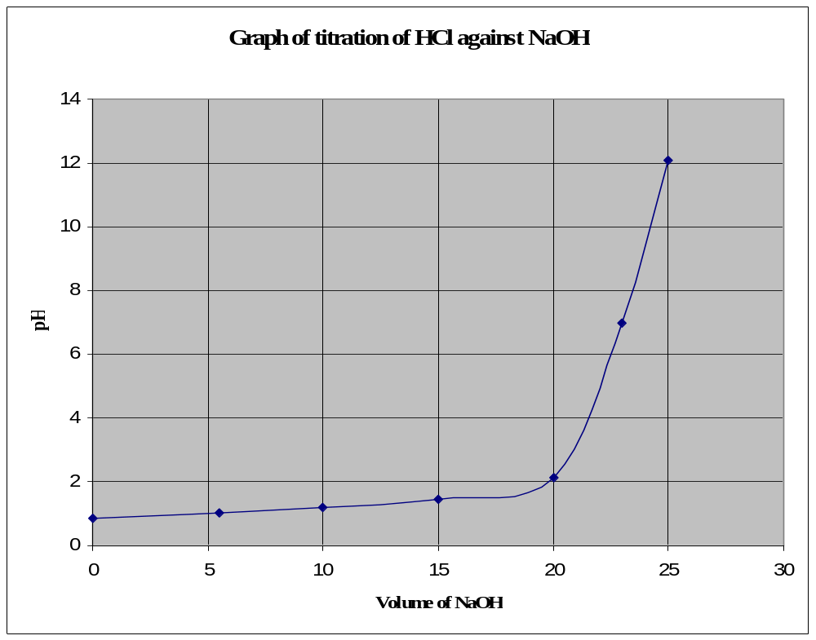

1.

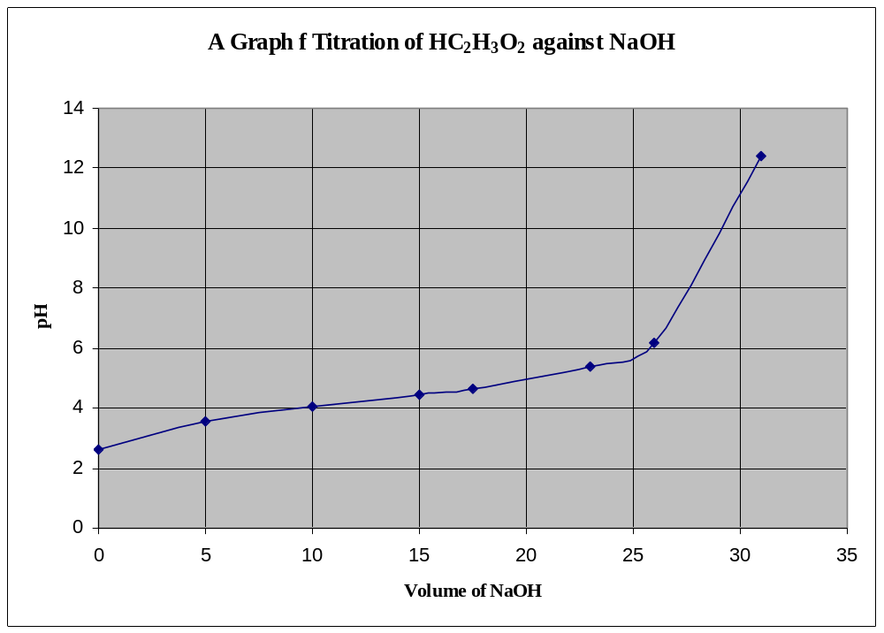

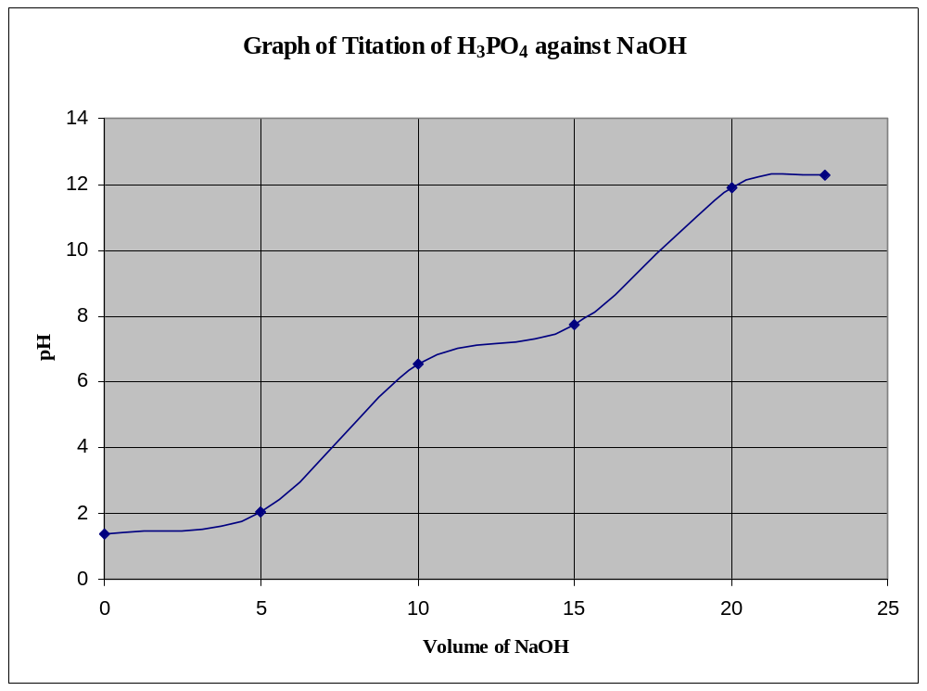

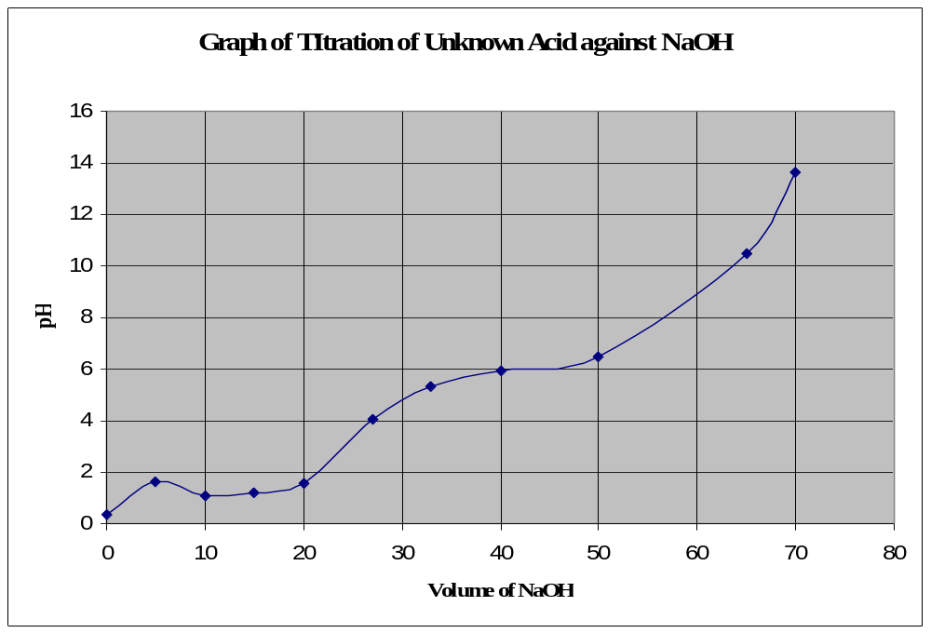

- The bottom half of both curves correspond to each other.
Some differences in both curves include:

- A higher initial pH.
- A gradual rising portion of the curve, called the buffer region appears before the steep rise to the equivalence point.
- The pH at the equivalence point is greater than 7.

- The first half – way to equivalence point of the Phosphoric acid maps on the graph to a pH of 1.9. This gives a pK_{a1} value of 1.9 and a K_{a1} value of 10^{-1.9} which equals 12.6 × 10⁻³.

The second half – way to equivalence point of the Phosphoric acid maps on the graph to a pH of 7.4. This gives a pK_{a2} value of 7.4 and a K_{a2} value of 10^{-7.4} which equals 3.98 × 10⁻⁸.

4. The first point from the graph is 1.2. Since this equals the pK_{a1}, the K_{a1} is 10^{-1.2} which equals 6.3 × 10⁻². This value almost equals the K_{a1} value of 6.5 × 10⁻² for Oxalic acid. Therefore the acid may be Oxalic acid.

The second point from the graph equals 6.1. Therefore pK_{a2} equals 6.1 and K_{a2} is 10^{-6.1} which equals 7.9 × 10⁻⁷ .

5. For the weak acid (HC₂H₃O₂) titration, methyl red was used which changes colour ( pink to yellow) earlier and slower over a large volume (≈ 10ml) of titrant, thereby giving a vague and false indication of the equivalence point.

Phenolphthalein is suitable in this titration because its colour change lies within the range of the basic region.

For the strong acid (HCl) titration, phenolphthalein was used. Even though the range of its colour change (colourless to pink) does not occur at the equivalence point, it occurs on the vertical position of the curve, where a single drop of base causes a large pH change and this shows that the titration is within a fraction of a drop from the equivalence point.

For the polyprotic acid (H₃PO₄) titration, methyl orange was used. From the results of the titration, there was no colour change meaning that the indicator was not suitable for the titration.

For the unknown acid titration, phenolphthalein was used. The colour change occurred at the basic region and this shows the acid is a weak one and the indicator was quite suitable for the titration.

